34.71: a) 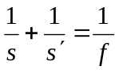 and taking its derivative with respect to s we have
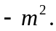 Images are always inverted longitudinally.
b) (i) Front face: 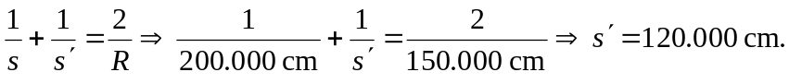
Rear face: 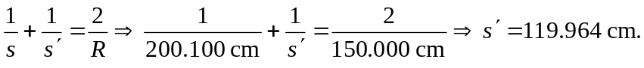
(ii) Front face:

Rear face:

(iii) So the front legs are magnified by 0.600000, the back legs by 0.599520, and the side legs by 0.359425, the average of the front and back longitudinal magnifications.

